Willie J. Davila Burgos
842-17-9562
INGL 3201-011
Prof. Jesus Lopez

Real Face of Jesus

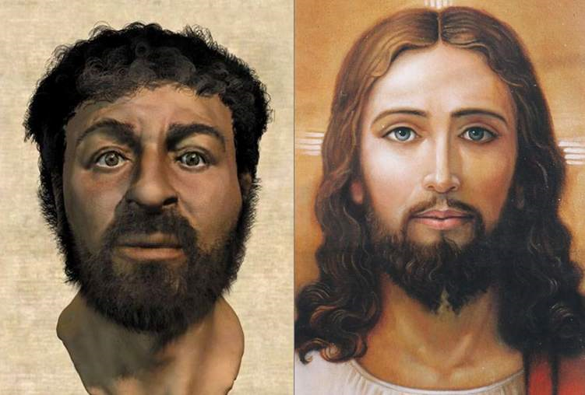

There’s a lot of misconception of Jesus appearance since he lived thousands of years ago. The Bible doesn’t give us an exact description of his features, meaning that his appearance is not important. However, the Bible does give us some idea of Jesus general appearance. For example, he was Jew with common futures, short hair and a beard with a strong body. One the biggest misconception is the Jesus was from African descent.
However, scientists have been trying to make a model of what Jesus looks like, calling it “The Real Face of Jesus”. They used cultural and archeological data as well as the physical and biological sciences to have a base of information they can use. Later, they use physical evidence of the period that Jesus was living, in this case a skull. This will determine the coloration of the hair. Finally using the Bible for main reference, they were able to create Jesus face along with some physical features such as height and weight.

